Sri Lanka Institute of Information

Technology



Lab Submission

07

**IT24103021**

**Rajapaksha R.P.V**

**Probability and Statistics - IT2120**

B.Sc. (Hons) in Information Technology

**Exercise**

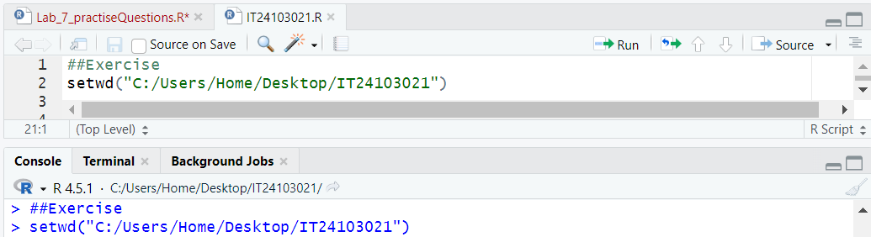

1. A train arrives at a station uniformly between 8:00 a.m. and 8:40 a.m. Let therandom variable X represent the number of minutes the train arrives after 8:00a.m. What is the probability that the train arrives between 8:10 a.m. and 8:25a.m.?

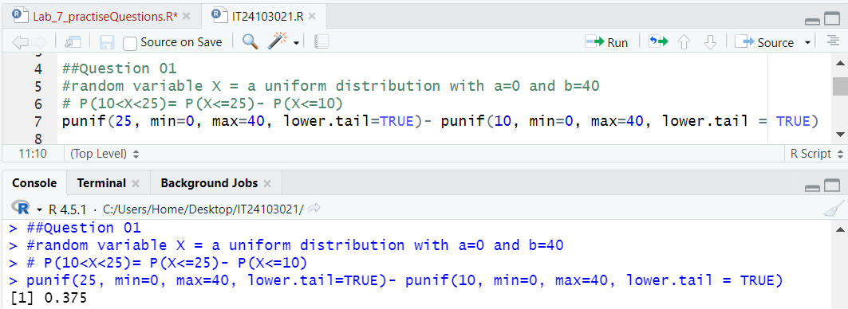

2. The time (in hours) to complete a software update is exponentially distributed with rate λ=1/3 . Find the probability that an update will take at most 2 hours.

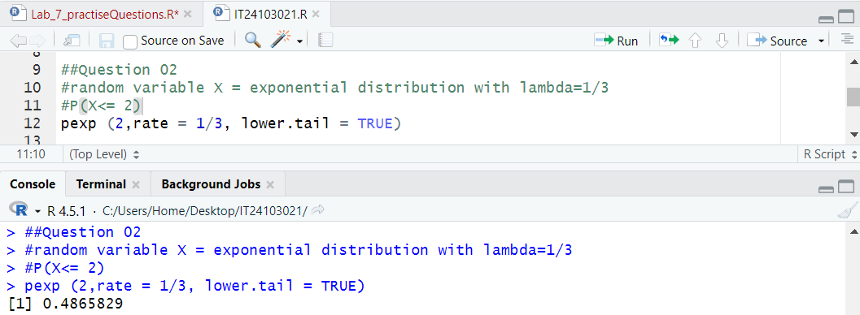

3. Suppose IQ scores are normally distributed with a mean of 100 and a standard deviation of 15.

i. What is the probability that a randomly selected person has an IQ above 130?

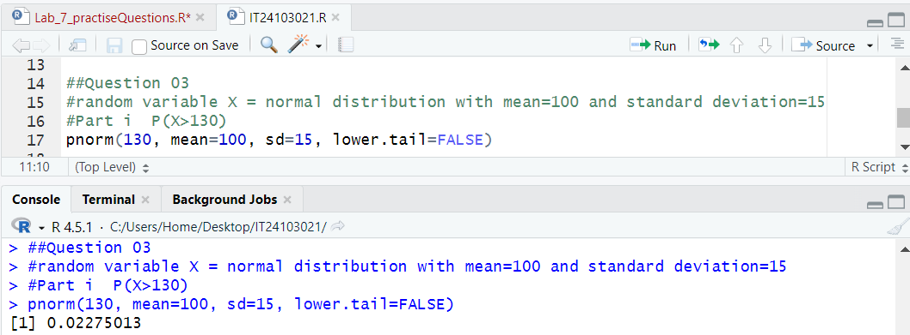

ii. What IQ score represents the 95th percentile?

